1. Menampilkan obat yang sudah mempunyai transaksi ataupun yang belum

Select nama_obat, pd.id_transaksi, jumlah_obat as terjual, tgl_transaksi, harga_obat

From obat as o

Left join penjualan_detail as pd

On o.id_obat = pd.id_obat

left join penjualan as p

on pd.id_transaksi=p.id_transaksi

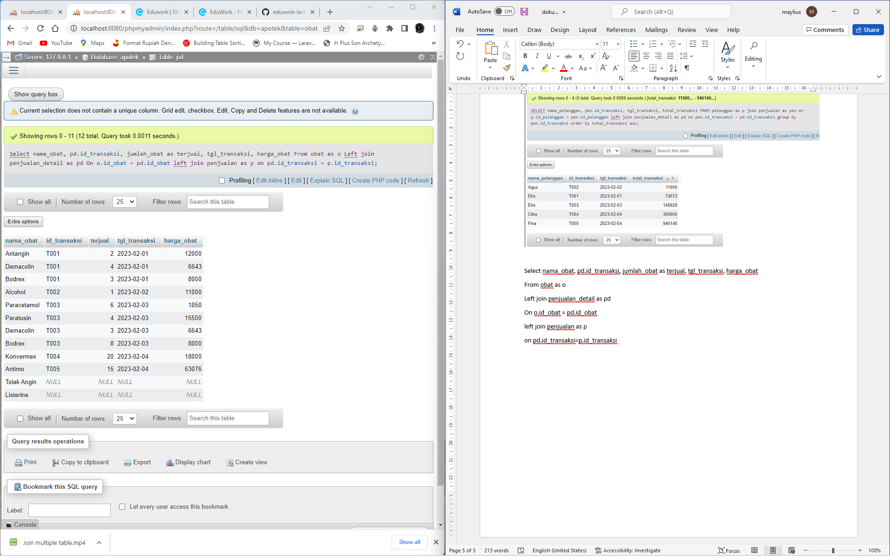

1. Mencari nama pelanggan dan transaksi yang terkecil hingga terbesar

SELECT nama_pelanggan, pen.id_transaksi, tgl_transaksi, total_transaksi

FROM pelanggan as p

join penjualan as pen

on p.id_pelanggan = pen.id_pelanggan

left join penjualan_detail as pd

on pen.id_transaksi = pd.id_transaksi

group by pen.id_transaksi

order by total_transaksi asc

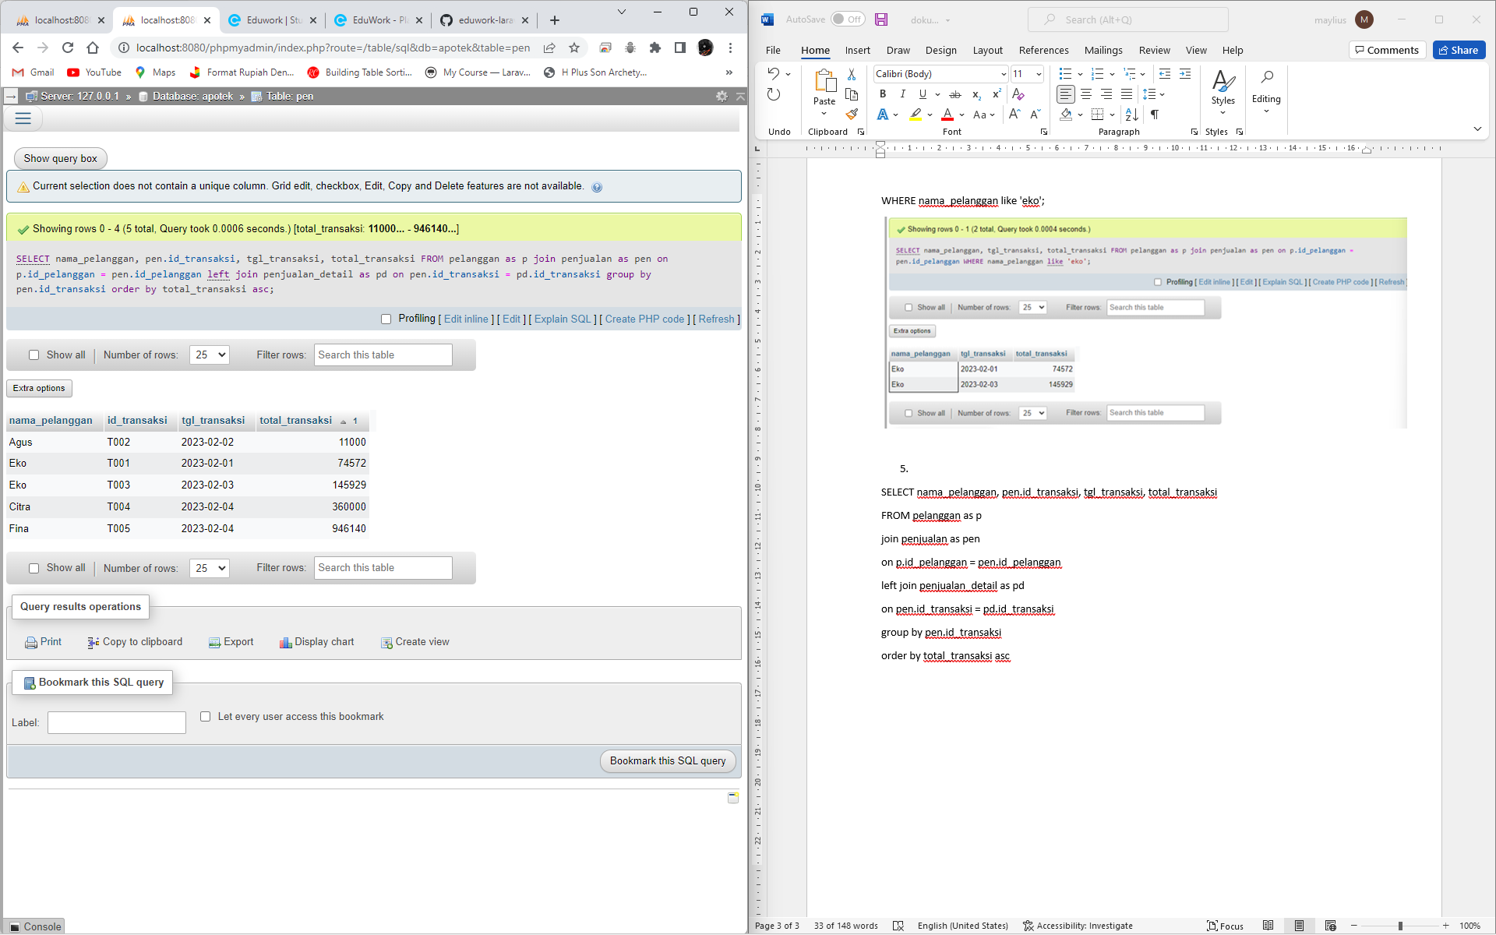

SELECT nama_pelanggan, pen.id_transaksi, tgl_transaksi, nama_obat, jumlah_obat, harga, total_harga

FROM pelanggan as p

join penjualan as pen

on p.id_pelanggan = pen.id_pelanggan

join penjualan_detail as pd

on pen.id_transaksi = pd.id_transaksi

join obat o

on o.id_obat = pd.id_obat

order by tgl_transaksi asc

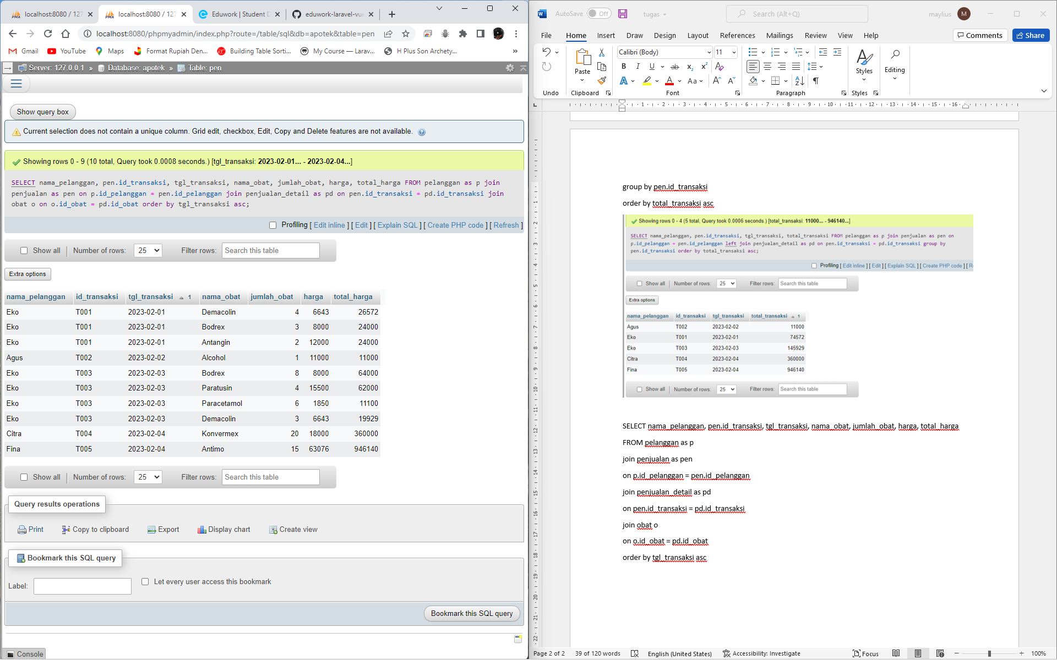

1. Menampilkan nama obat dan penjualan berapa di tanggal berapa

SELECT nama_obat, tgl_transaksi, jumlah_obat as terjual, harga, total_harga

FROM pelanggan as p

join penjualan as pen

on p.id_pelanggan = pen.id_pelanggan

join penjualan_detail as pd

on pen.id_transaksi = pd.id_transaksi

join obat o

on o.id_obat = pd.id_obat

order by tgl_transaksi asc

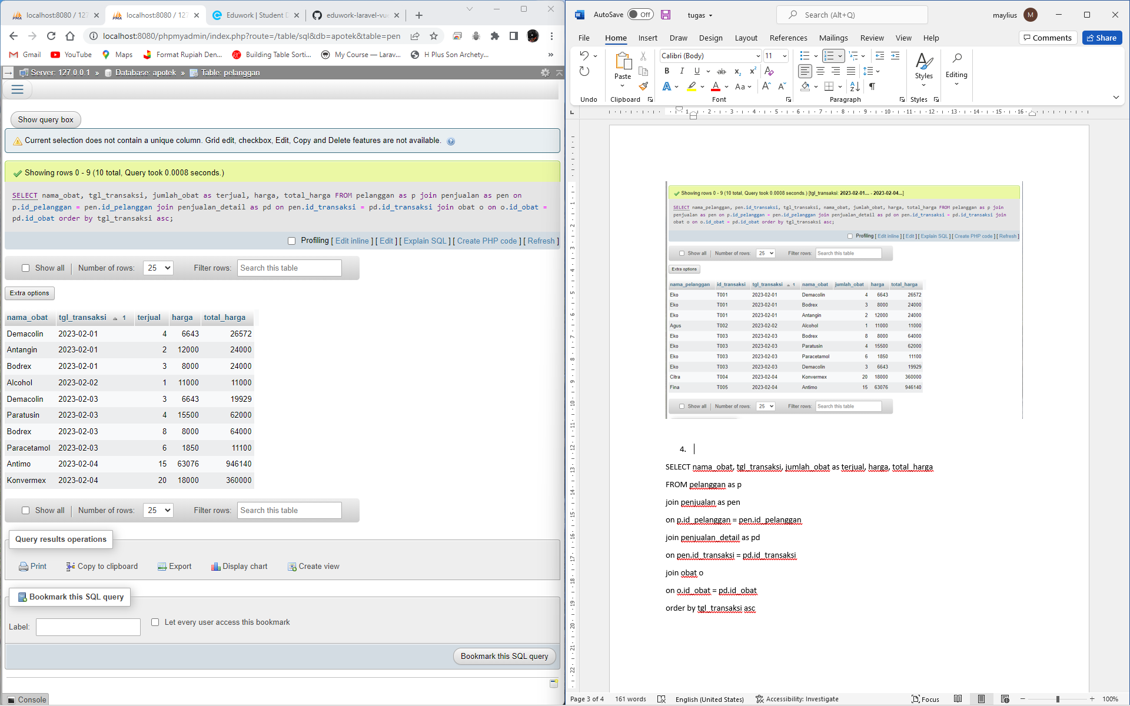

1. Menampilkan transaksi per tanggal, pembayaran dan kembalian

SELECT tgl_transaksi, nama_pelanggan, total_transaksi as pembelian, total_bayar as Bayar, total_kembalian as Kembalian

FROM pelanggan as p

Right join penjualan as pen

on p.id_pelanggan = pen.id_pelanggan

left join penjualan_detail as pd

on pen.id_transaksi = pd.id_transaksi

join obat o

on o.id_obat = pd.id_obat

group by id_transaksi

order by tgl_transaksi asc

